GIT CHALLENGES
Resolve Merge Conflicts
Create a merge conflict intentionally (two users editing the same line).
Initialized a Git repository using git init, and verified the status using git status and created a new folder git-conflict-demo
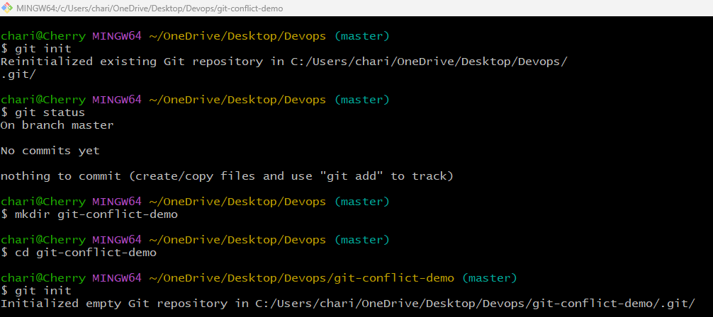
Added file.txt to staging and created the initial commit. Created two branches user1 and user2. Switched to user1
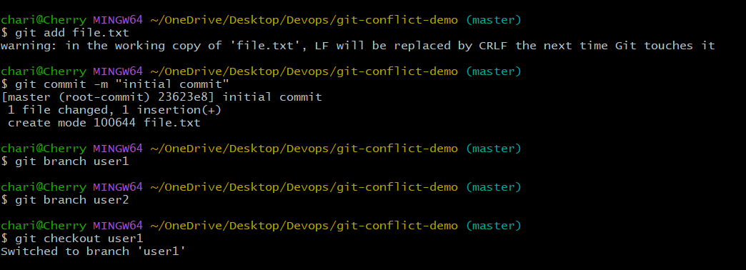
Switched to user1 branch and modified file.txt with content "AAAA from user1".
Added and committed changes in user1 branch.
Switched to user2 branch and modified the same file with content "BBBB from user2".
Added and committed changes in user2 branch.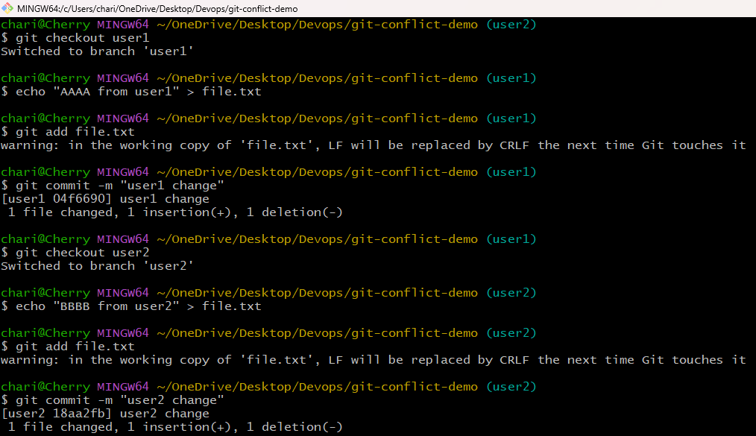
A merge conflict occurred due to changes in the same line, conflict markers appeared in the file, and it was resolved by editing the content to "AAAA and BBBB".
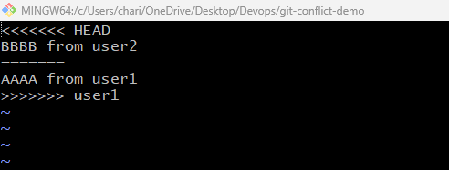
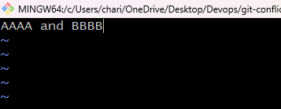
Merge was attempted and a conflict occurred, the file was edited to resolve it, changes were added and committed, and the final merged content "AAAA and BBBB" was verified
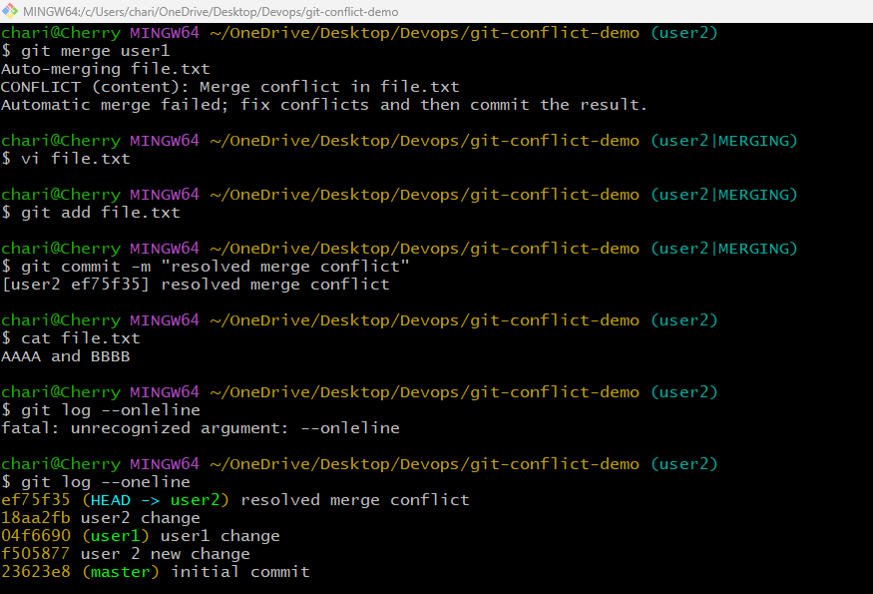
1.Resolve the conflict and push the changes.
The conflict is resolved.
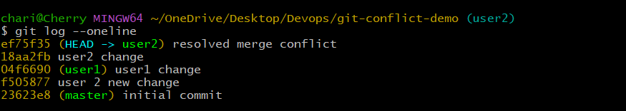
The user2 branch was pushed to GitHub, commits including the resolved merge conflict are visible, and an option is available to compare and create a pull request.
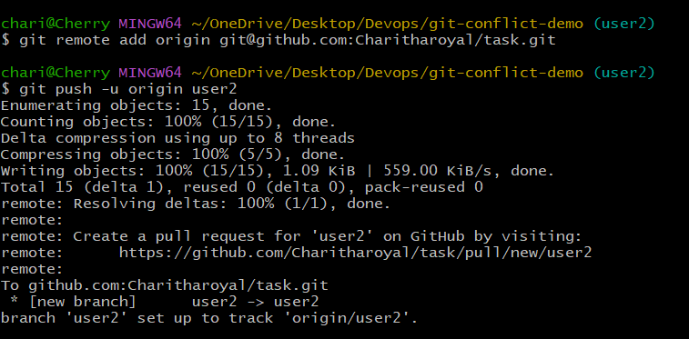
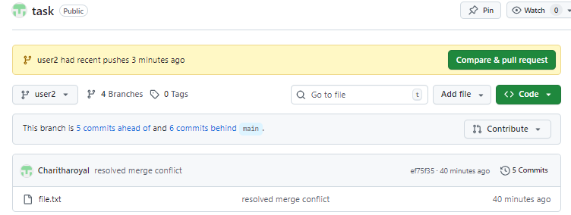
2. Recover Deleted Branch
The user1 branch was deleted and then successfully recovered using reflog by identifying the commit ID and recreating the branch.
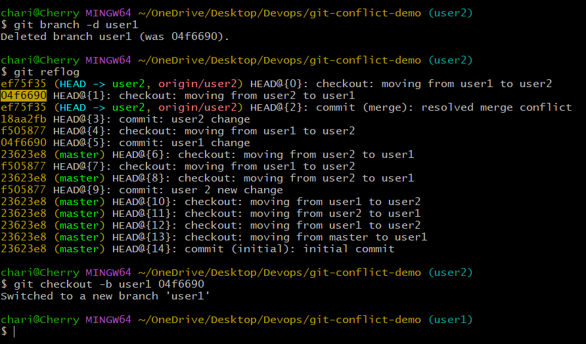
3. Delete a local branch and then recover it using the reflog.
A local branch was deleted and then recovered using reflog by locating the commit ID and recreating the branch from that commit.

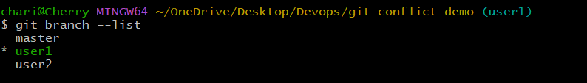
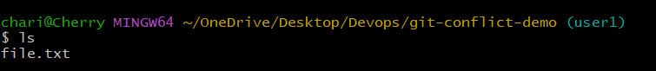
4. Undo Wrong Push
Push a wrong commit to GitHub, then undo it without losing history
Created a file in user1 branch, added and committed the changes, pushed to user1, then used revert command to remove that commit and pushed again, after which the file was no longer visible on GitHub.
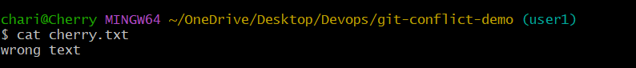
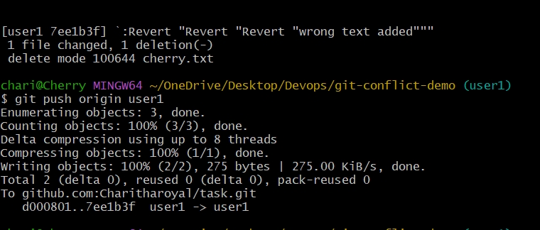
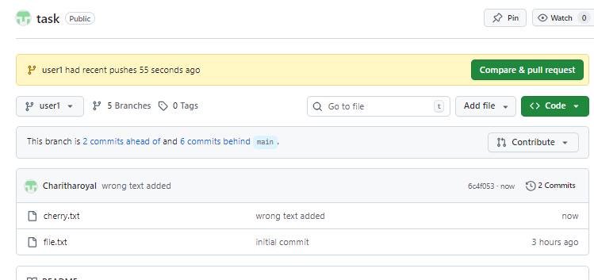
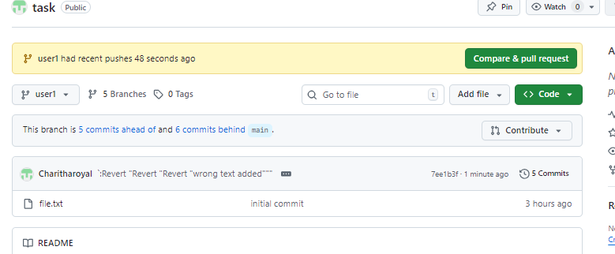
1.Amend a Commit
Make a commit, then add a missing file to it using git commit –amend
Created new files in user1 branch, added and committed them, then used amend command to update the commit message to "added 3 files" and verified it using git log.
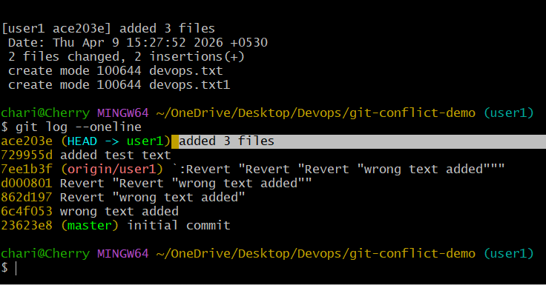
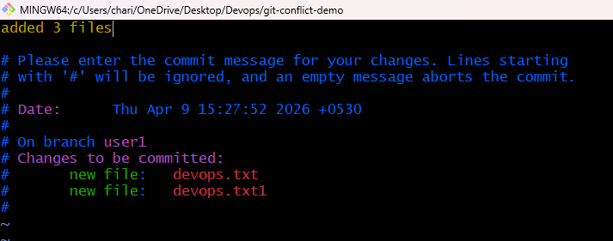
2.Cherry-pick a Commit
Take a specific commit from one branch and apply it to another branch
Created a new file release.txt in user1 branch, added and committed it with message "added release", checked the commit id using git log
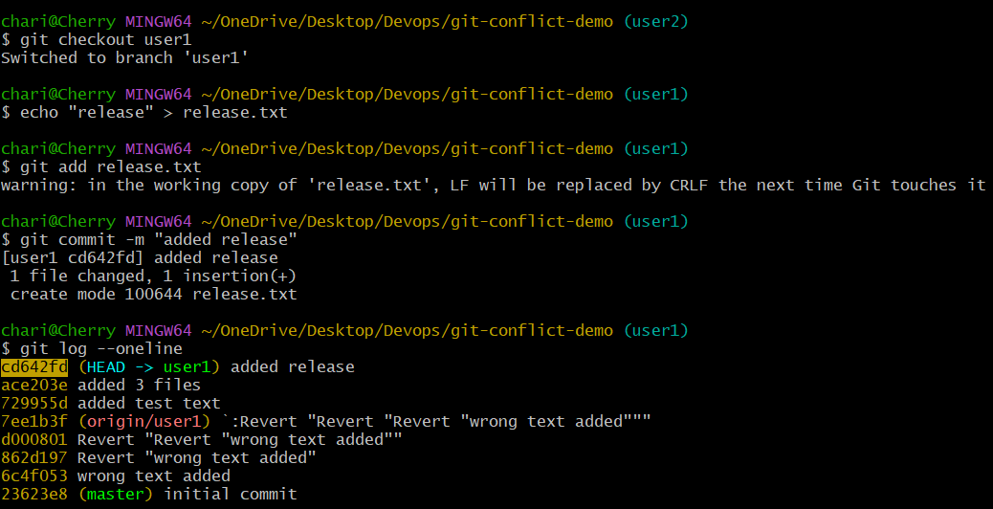
switched to user2 branch and applied that specific commit using cherry-pick command, which successfully added the file to user2 branch
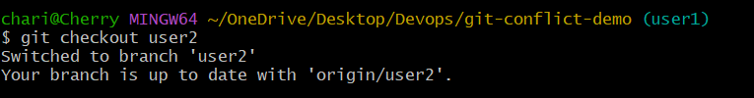
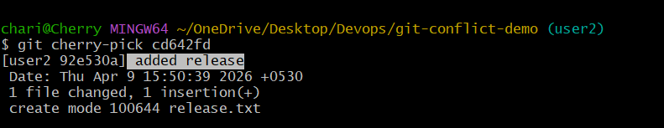
3.Interactive Rebase
Reorder and squash multiple commits into a single clean commit
Created multiple files a, b, and c in user2 branch, added each file separately and committed them one by one with different commit messages for each file
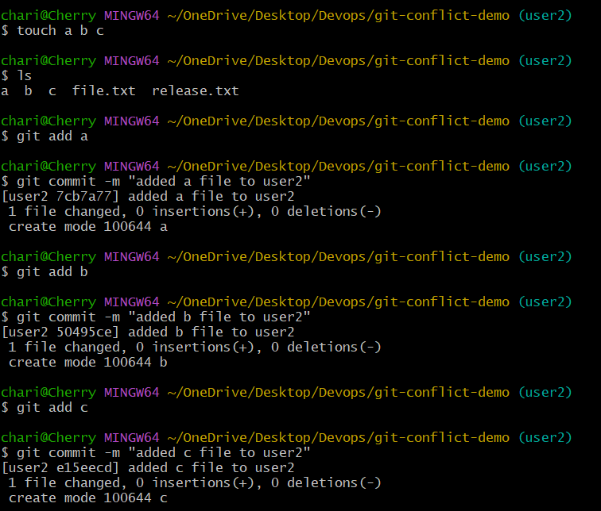
Viewed commit history using git log to identify recent commits, then started interactive rebase on the last 3 commits using rebase command to reorder or squash them.
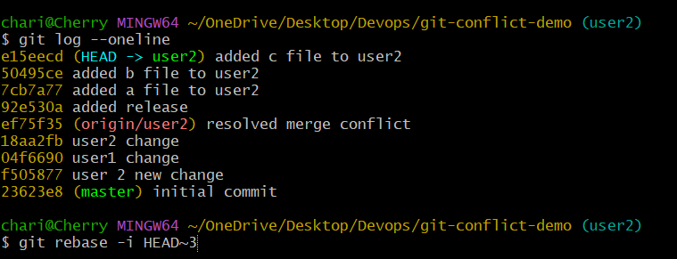
Started interactive rebase on the last 3 commits, changed pick to squash for multiple commits to combine them, and successfully squashed all commits into a single clean commit.
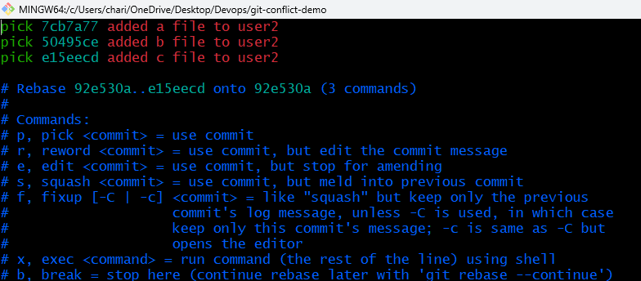
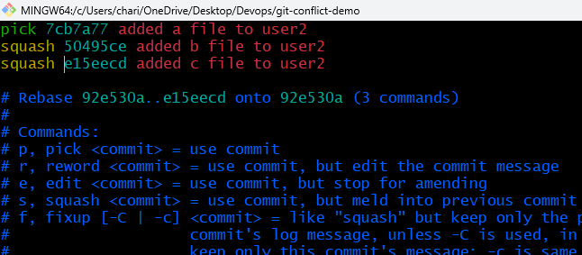
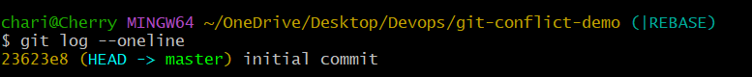
4. Tagging & Release
Create a version tag (v1.0), push it to GitHub, then delete and restore it
Created a new file application.txt in user1 branch, added content to it, staged the file and committed it with the message "adding version to file".
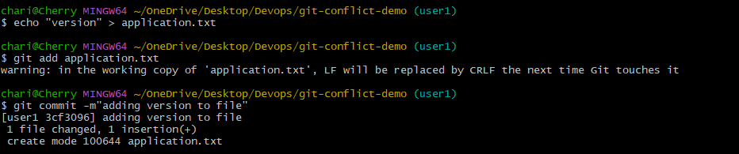
Created a tag v1.0 in user1 branch, verified the tag locally, pushed both branch and tag to remote repository, and confirmed the tag is visible in GitHub.
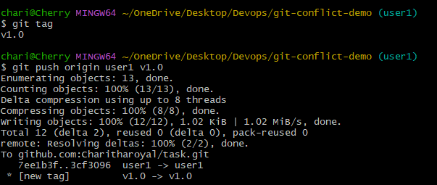

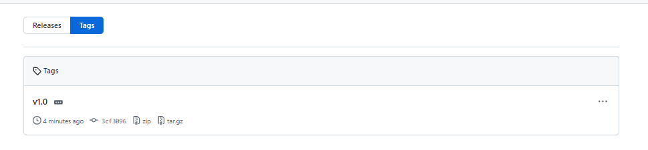
Deleted the existing tag v1.0, verified it was removed, then recreated the tag pointing to a specific commit and confirmed it again locally and on the remote repository.
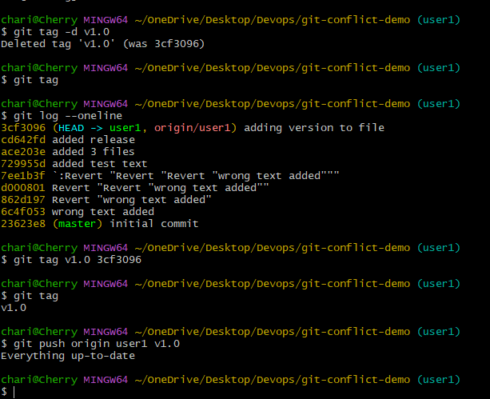
5. Clone with Sparse Checkout
Clone only a subdirectory of a repo using sparse checkout

Reset vs Revert Challenge
1.Demonstrate the difference between git reset --hard and git revert in a repo
Git Reset
Viewed commit history using git log, then used reset command to move back to the previous commit, and verified the updated commit history again using git log

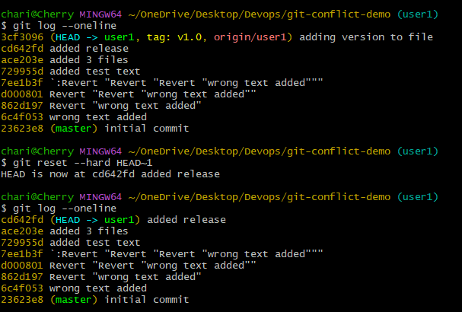
Git Revert
Checked commit history using git log, then used revert command on the latest commit, edited the commit message, and created a new commit that removed the changes from the previous commit.
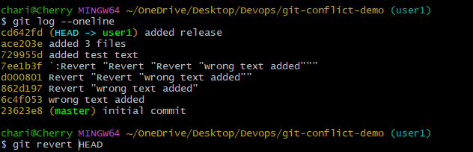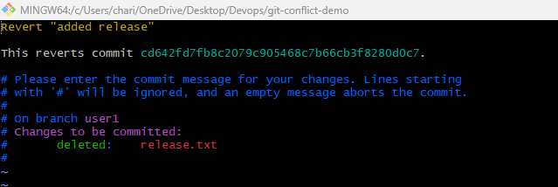
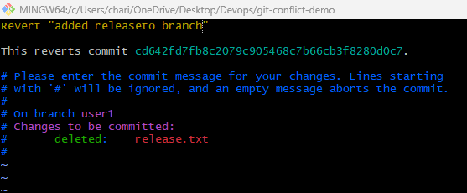
Reverted the latest commit successfully which deleted the release.txt file, and verified the updated commit history using git log showing the new revert commit on top.

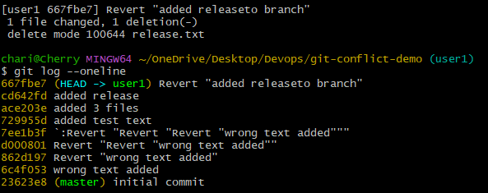
Detached HEAD Challenge
2.Checkout a specific commit (detached HEAD state) and create a new branch from it
Created and committed document.txt and pdf.txt while in a detached HEAD state.
Verified file contents successfully, but commits are not linked to any branch yet.
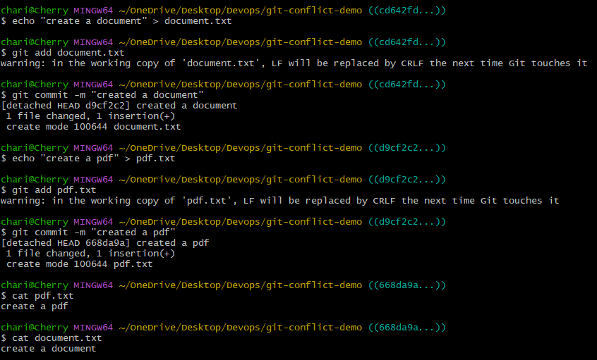
Checked commit history using git log --oneline and navigated to a specific commit using git checkout, entering detached HEAD state.
Verified working tree is clean, but current position is not on any branch (HEAD detached from branch)
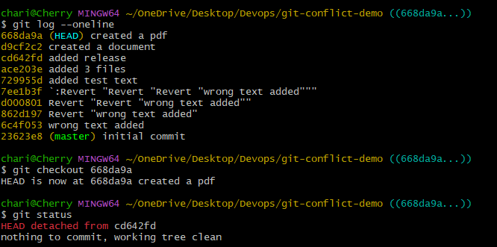
Added new changes in detached HEAD state and committed them successfully.
Created a new branch (det-branch) to preserve the detached commit and switched to it
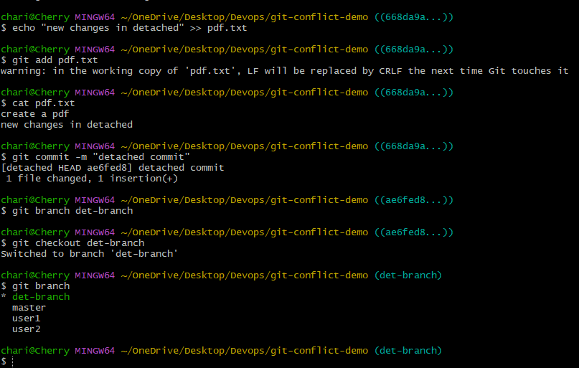
Git Hooks Challenge
1.Configure a pre-commit hook to reject commits without a message format (e.g., must start with JIRA-XXX)
Configured pre-commit hook and made it executable in .git/hooks.
Commit failed due to invalid message format (must follow JIRA-<number>).
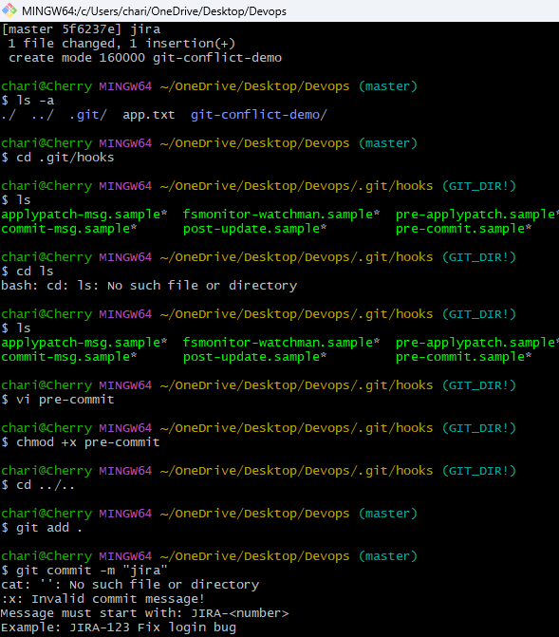
Created a pre-commit hook script to validate commit messages using a regex pattern (^JIRA-[0-9]+).
The hook blocks commits with invalid messages and enforces the required JIRA ticket format
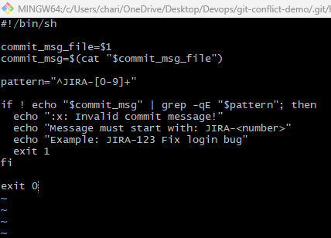
Navigated to .git/hooks directory and removed the pre-commit hook file.
This disables commit message validation, allowing commits without JIRA format.
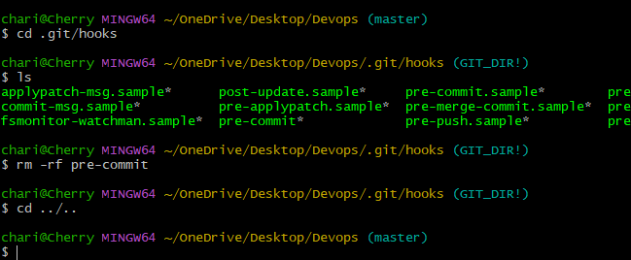
Squash Merge vs Rebase Merge
2.Show the difference between squash merge and rebase merge with evidence
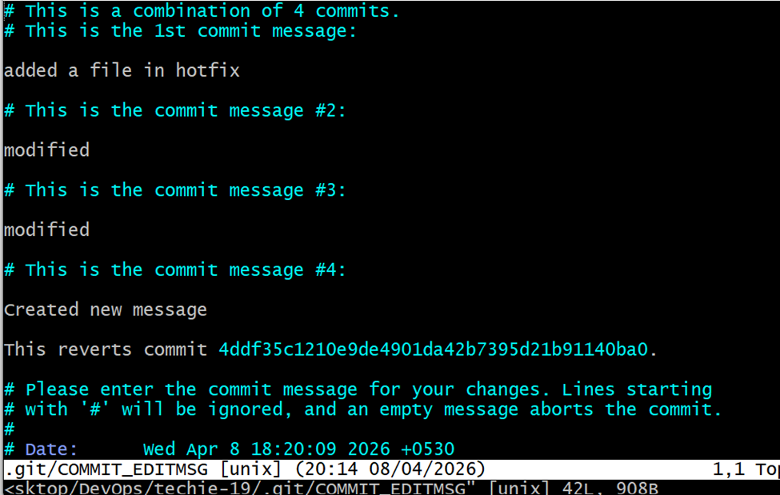
Fork & Pull Request Workflow
Fork a repo, make a change, and submit a pull request to the original repo
Created a pull request, requested review, and received approval from a collaborator.
Successfully merged the pull request into the main branch and closed it.

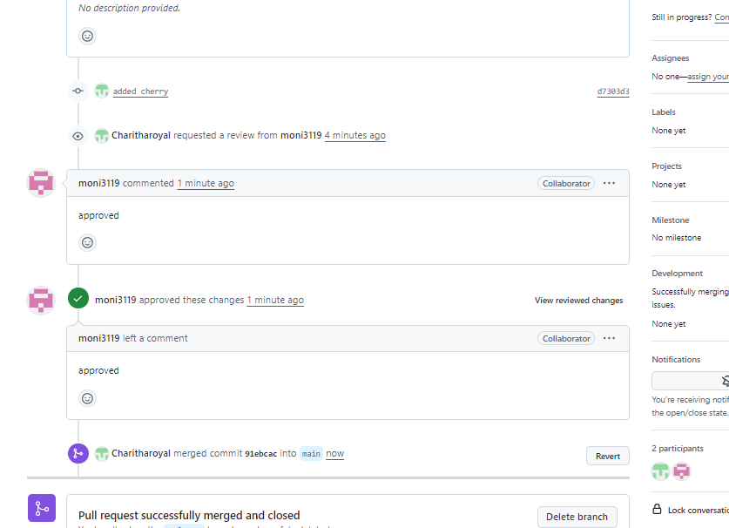
Recover Lost Commit
Commit something, reset hard, and then recover it using git reflog
Viewed commit history and performed a hard reset to the previous commit using git reset --hard HEAD~1.
Used git reflog to track changes and confirm commit history after reset
